
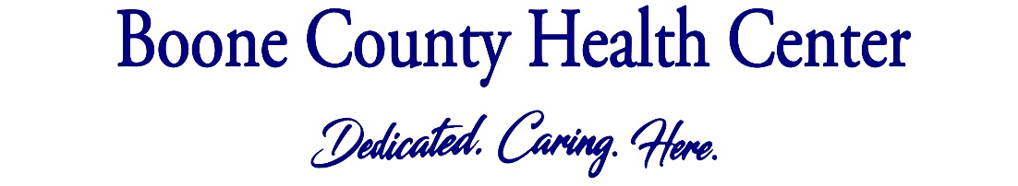

KINDERGARTEN SCHOOL PHYSICAL
Your child will need their kindergarten physical this year. Here’s what to expect:
Vaccines. Your child will get two vaccines recommended by the Centers for Disease Control and Prevention (CDC):
- ProQuad – MMR & varicella combination
- Kinrix – Tdap & polio combination
*If your child is on Medicaid or you have no insurance, make sure you come to the clinic in Albion for vaccines. Families with private insurance can get vaccines at any of our clinics.
Exam. We will check a urine sample. Please do not forget to schedule your eye appointment with your eye doctor.
Talk. We will talk with your child about sleep, physical activity, nutrition, relationships, decision making and much more. This is a great time for parents to ask questions or talk about concerns they have for their child’s well-being.
What to Bring:
Full bladder – so we can get a urine sample
Immunization records
When to schedule: The sooner the better as the schedule gets full in July and August.
How to schedule: Call your local clinic to schedule your child’s kindergarten physical.

Boone County Medical Clinic: 402-395-5013
Cedar Rapids Medical Clinic: 308-358-0615
Elgin Veterans’ Medical Clinic: 402-843-5910
Nance County Medical Clinic: 308-536-2446
Newman Grove Medical Clinic: 402-447-6214
Spalding Medical Clinic: 308-497-2485
St. Edward Medical Clinic: 402-678-2232

